<https://www.hcltech.com/blogs/azure-api-management-benefits-and-limitations>

<https://www.biztalkbill.com/2018/07/23/azure-api-management/>

<https://docs.microsoft.com/en-us/azure/api-management/>

**WEBAPI**

Today, a web-based application is not enough to reach it's customers. People are very smart, they are using iphone, mobile, tablets etc

devices its changes daily

Actually, we are moving from the web towards apps world

if you like to expose your service data to the browsers and as well as all these modern devices apps in fast and simple way, you should have an API which is compatible with browsers and all these devices.

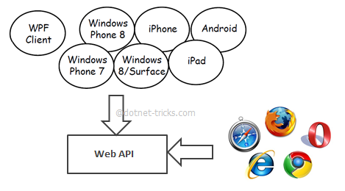

Web API is the great framework for exposing your data and service to different-different device

Web API is open source an ideal platform for building REST-ful services over the .NET Framework.

APIs are the most optimized way of sharing data or providing services, where technology is not a limitation

It means one can use a Java API for fetching data in .Net application

Major drawback for APIs is that one cannot track the utilization of the APIs or cannot analyze the performance directly

**API Management**

Instead of accessing the API directly, you can register API into APIM. So user can’t directly access API instead of going APIM. Now APIM take care of authorization, Oauth and Open ID connect and all

API management platform, which can help in overcoming such drawbacks

Using API management platform, one can publish their existing APIs directly from on premise, cloud or any external server, and it will be available to customers, partners and even to developers within no time

It also provides a developer portal, from where any developer either from client side or internally, one can directly view or execute these APIs

While consuming an API, another challenge, which API consumers generally face, is lack of documentation. This challenge is also taken care by Azure API Management. In this, one can provide documentation at various places while declaring APIs for publishing, like at method, parameters and response

API Management also provides automatic scaling of instances depending upon the traffic load. One can also define various policies like rate limit, quota, XML to JSON conversion etc., for one’s API calls. One can also apply authentication on the API and authorize application to access the API

SOAP is not supported

**Security**

Three ways to secure API in APIM

1. When you register your API to APIM services, you will get primary key and secondary key under subscription. One of these needs to be passed in the header of the request to the APIM. This protects your API from being called by anyone without a subscription key. Request without a key are stopped at the APIM gateway, never reaching your API backend.
2. Another one is Oauth 2.0
3. Third one is Open ID Connect

Oauth: <https://docs.microsoft.com/en-us/azure/api-management/api-management-howto-oauth2>